Chapter-1
INTRODUCTION
1.1 Introduction
An Embedded System is a combination of computer hardware and software, and perhaps additional mechanical or other parts, designed to perform a specific function. A good example is the microwave oven. Almost every household has one, and tens of millions of them are used every day, but very few people realize that a processor and software are involved in the preparation of their lunch or dinner.
This is in direct contrast to the personal computer in the family room. It too is comprised of computer hardware and software and mechanical components (disk drives, for example). However, a personal computer is not designed to perform a specific function rather; it is able to do many different things. Many people use the term general-purpose computer to make this distinction clear. As shipped, a general-purpose computer is a blank slate; the manufacturer does not know what the customer will do wish it. One customer may use it for a network file server another may use it exclusively for playing games, and a third may use it to write the next great American novel.
Frequently, an embedded system is a component within some larger system. For example, modern cars and trucks contain many embedded systems. One embedded system controls the anti-lock brakes, other monitors and controls the vehicle’s emissions, and a third displays information on the dashboard. In some cases, these embedded systems are connected by some sort of a communication network, but that is certainly not a requirement.
At the possible risk of confusing you, it is important to point out that a general-purpose computer is itself made up of numerous embedded systems. For example, my computer consists of a keyboard, mouse, video card, modem, hard drive, floppy drive, and sound card-each of which is an embedded system. Each of these devices contains a processor and software and is designed to perform a specific function. For example, the modem is designed to send and receive digital data over analog telephone line. That’s it and all of the other devices can be summarized in a single sentence as well.
If an embedded system is designed well, the existence of the processor and software could be completely unnoticed by the user of the device. Such is the case for a microwave oven, VCR, or alarm clock. In some cases, it would even be possible to build an equivalent device that does not contain the processor and software. This could be done by replacing the combination with a custom integrated circuit that performs the same functions in hardware. However, a lot of flexibility is lost when a design is hard-cooled in this way. It is much easier, and cheaper, to change a few lines of software than to redesign a piece of custom hardware.
1.1.1 Real Time Systems
One subclass of embedded is worthy of an introduction at this point. As commonly defined, a real-time system is a computer system that has timing constraints. In other words, a real-time system is partly specified in terms of its ability to make certain calculations or decisions in a timely manner. These important calculations are said to have deadlines for completion. And, for all practical purposes, a missed deadline is just as bad as a wrong answer.
The issue of what if a deadline is missed is a crucial one. For example, if the real-time system is part of an airplane’s flight control system, it is possible for the lives of the passengers and crew to be endangered by a single missed deadline. However, if instead the system is involved in satellite communication, the damage could be limited to a single corrupt data packet. The more severe the consequences, the more likely it will be said that the deadline is “hard” and thus, the system is a hard real-time system. Real-time systems at the other end of this discussion are said to have “soft” deadlines.
1.1.2 Application Areas
Nearly 99 per cent of the processors manufactured end up in embedded systems. The embedded system market is one of the highest growth areas as these systems are used in very market segment- consumer electronics, office automation, industrial automation, biomedical engineering, wireless communication, data communication, telecommunications, transportation, military and so on.
1.1.3 Consumer Appliances
At home we use a number of embedded systems which include digital camera, digital diary, DVD player, electronic toys, microwave oven, remote controls for TV and air-conditioner, VCO player, video game consoles, video recorders etc. Today’s high-tech car has about 20 embedded systems for transmission control, engine spark control, air-conditioning, navigation etc. Even wristwatches are now becoming embedded systems. The palmtops are powerful embedded systems using which we can carry out many general-purpose tasks such as playing games and word processing.
1.1.4 Office Automation
The office automation products using embedded systems are copying machine, fax machine, key telephone, modem, printer, scanner etc.

1.1.5 Industrial Automation
Today a lot of industries use embedded systems for process control. These include pharmaceutical, cement, sugar, oil exploration, nuclear energy, electricity generation and transmission. The embedded systems for industrial use are designed to carry out specific tasks such as monitoring the temperature, pressure, humidity, voltage, current etc., and then take appropriate action based on the monitored levels to control other devices or to send information to a centralized monitoring station. In hazardous industrial environment, where human presence has to be avoided, robots are used, which are programmed to do specific jobs. The robots are now becoming very powerful and carry out many interesting and complicated tasks such as hardware assembly.
1.1.6 Medical Electronics
Almost every medical equipment in the hospital is an embedded system. These equipments include diagnostic aids such as ECG, EEG, blood pressure measuring devices, X-ray scanners; equipment used in blood analysis, radiation, colonscopy, endoscopy etc. Developments in medical electronics have paved way for more accurate diagnosis of diseases.
1.1.7 Computer Networking
Computer networking products such as bridges, routers, Integrated Services Digital Networks (ISDN), Asynchronous Transfer Mode (ATM), X.25 and frame relay switches are embedded systems which implement the necessary data communication protocols. For example, a router interconnects two networks. The two networks may be running different protocol stacks. The router’s function is to obtain the data packets from incoming pores, analyze the packets and send them towards the destination after doing necessary protocol conversion. Most networking equipments, other than the end systems (desktop computers) we use to access the networks, are embedded systems.
1.1.8 Telecommunications
In the field of telecommunications, the embedded systems can be categorized as subscriber terminals and network equipment. The subscriber terminals such as key telephones, ISDN phones, terminal adapters, web cameras are embedded systems. The network equipment includes multiplexers, multiple access systems, Packet Assemblers Dissemblers (PADs), sate11ite modems etc. IP phone, IP gateway, IP gatekeeper etc. are the latest embedded systems that provide very low-cost voice communication over the Internet.

1.1.9 Wireless Technologies
Advances in mobile communications are paving way for many interesting applications using embedded systems. The mobile phone is one of the marvels of the last decade of the 20’h century. It is a very powerful embedded system that provides voice communication while we are on the move. The Personal Digital Assistants and the palmtops can now be used to access multimedia services over the Internet. Mobile communication infrastructure such as base station controllers, mobile switching centers are also powerful embedded systems.
1.1.10 Security
Security of persons and information has always been a major issue. We need to protect our homes and offices; and also the information we transmit and store. Developing embedded systems for security applications is one of the most lucrative businesses nowadays. Security devices at homes, offices, airports etc. for authentication and verification are embedded systems. Encryption devices are nearly 99 per cent of the processors that are manufactured end up in~ embedded systems. Embedded systems find applications in . every industrial segment- consumer electronics, transportation, avionics, biomedical engineering, manufacturing, process control and industrial automation, data communication, telecommunication, defense, security etc. Used to encrypt the data/voice being transmitted on communication links such as telephone lines. Biometric systems using fingerprint and face recognition are now being extensively used for user authentication in banking applications as well as for access control in high security buildings.
1.1.11 Finance
Financial dealing through cash and cheques are now slowly paving way for transactions using smart cards and ATM (Automatic Teller Machine, also expanded as Any Time Money) machines. Smart card, of the size of a credit card, has a small micro-controller and memory; and it interacts with the smart card reader! ATM machine and acts as an electronic wallet. Smart card technology has the capability of ushering in a cashless society. Well, the list goes on. It is no exaggeration to say that eyes wherever you go, you can see, or at least feel, the work of an embedded system.

1.1.12 Microcontrollers Used For

Like all good things, this powerful component is basically very simple. It is made by mixing tested and high- quality “ingredients” (components) as per following receipt:
- The simplest computer processor is used as the “brain” of the future system.
- Depending on the taste of the manufacturer, a bit of memory, a few A/D converters, timers, input/output lines etc. are added
- All that is placed in some of the standard packages.
- Simple software able to control it all and which everyone can easily learn about has been developed.
On the basis of these rules, numerous types of microcontrollers were designed and they quickly became man’s invisible companion. Their incredible simplicity and flexibility conquered us a long time ago and if you try to invent something about them, you should know that you are probably late, someone before you has either done it or at least has tried to do it.
The following things have had a crucial influence on development and success of the microcontrollers:
- Powerful and carefully chosen electronics embedded in the microcontrollers can 5milliseconds5 or via input/output devices (switches, push buttons, sensors, LCD displays, relays etc.), control various processes and devices such as industrial automation, electric current, temperature, engine performance etc.
- Very low prices enable them to be embedded in such devices in which, until recent time it was not worthwhile to embed anything. Thanks to that, the world is overwhelmed today with cheap automatic devices and various “smart” appliances.
- Prior knowledge is hardly needed for programming. It is sufficient to have a PC (software in use is not demanding at all and is easy to learn) and a simple device (called the programmer) used for “loading” raedy-to-use programs into the microcontroller.
1.3 Block Design Proposal for the System
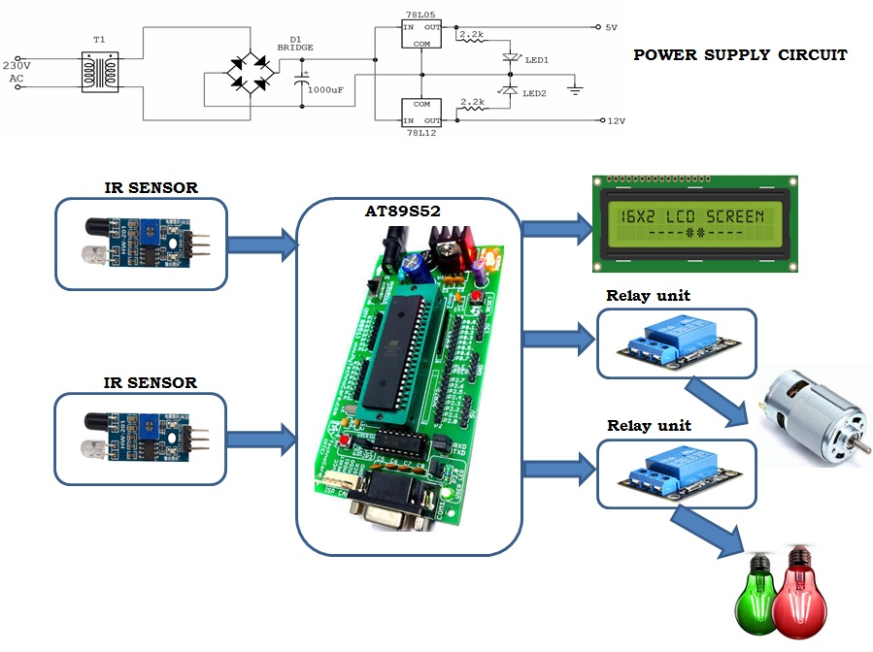
Fig 1.1 Block Design Proposal for the System
Chapter-2
DESCRIPTION OF HARDWARE COMPONENTS
2.1 AT89S52
The AT89S52 is a low-power, high-performance CMOS 8-bit microcontroller with 8K bytes of in-system programmable Flash memory. The device is manufactured using Atmel’s high-density nonvolatile memory technology and is compatible with the industry-standard 80C51 instruction set and pin out. The on-chip Flash allows the program memory to be reprogrammed in-system or by a conventional nonvolatile memory pro-grammar. By combining a versatile 8-bit CPU with in-system programmable Flash on a monolithic chip, the Atmel AT89S52 is a powerful microcontroller, which provides a highly flexible and cost-effective solution to many, embedded control applications.
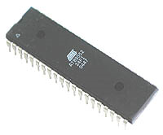
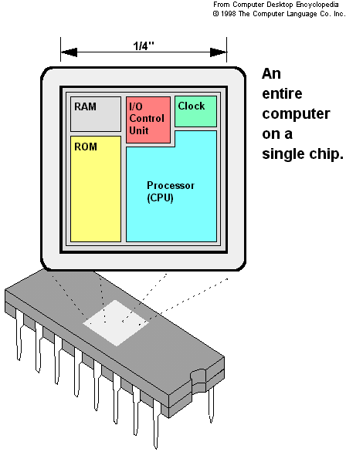
Fig 2.1: AT89S52 Microcontroller
The AT89S52 provides the following standard features: 8K bytes of Flash, 256 bytes of RAM, 32 I/O lines, Watchdog timer, two data pointers, three 16-bit timer/counters, a six-vector two-level interrupt architecture, a full duplex serial port, on-chip oscillator, and clock circuitry. In addition, the AT89S52 is designed with static logic for operation down to zero frequency and supports two software selectable power saving modes. The Idle Mode stops the CPU while allowing the RAM, timer/counters, serial port, and interrupt system to continue functioning. The Power-down mode saves the RAM con-tents but freezes the oscillator, disabling all other chip functions until the next interrupt of the three microcontrollers, 8051 is the most preferable. Microcontroller supports both serial and parallel communication.
In the concerned project 8052 microcontroller is used. Here microcontroller used is AT89S52, which is manufactured by ATMEL laboratories. The 8051 is the name of a big family of microcontrollers. The device which we are going to use along this tutorial is the 'AT89S52' which is a typical 8051 microcontroller manufactured by Atmel™. Note that this part doesn't aim to explain the functioning of the different components of AT89S52 microcontroller, but rather to give you a general idea of the organization of the chip and the available features, which shall be explained in detail along this tutorial.
The block diagram provided by Atmel™ in their datasheet showing the architecture the 89S52 device can seem very complicated, and since we are going to use the C high level language to program it, a simpler architecture can be represented as the figure 1.2.A.
This figures shows the main features and components that the designer can interact with. You can notice that the 89S52 has 4 different ports, each one having 8 Input/output lines providing a total of 32 I/O lines. Those ports can be used to output DATA and orders do other devices, or to read the state of a sensor, or a switch. Most of the ports of the 89S52 have 'dual function' meaning that they can be used for two different functions: the fist one is to perform input/output operations and the second one is used to implement special features of the microcontroller like counting external pulses, interrupting the execution of the program according to external events, performing serial data transfer or connecting the chip to a computer to update the software.
2.1.1 Necessity of Microcontrollers
Microprocessors brought the concept of programmable devices and made many applications of intelligent equipment. Most applications, which do not need large amount of data and program memory, tended to be costly.
The microprocessor system had to satisfy the data and program requirements so, sufficient RAM and ROM are used to satisfy most applications .The peripheral control equipment also had to be satisfied. Therefore, almost all-peripheral chips were used in the design. Because of these additional peripherals cost will be comparatively high.
An Address latch for separating address from multiplex address and data.32-KB RAM and 32-KB ROM to be able to satisfy most applications. As also Timer / Counter, Parallel programmable port, Serial port, and Interrupt controller are needed for its efficient applications.
In comparison a typical Micro controller 8051 chip has all that the 8051 board has except a reduced memory as follows.
4K bytes of ROM as compared to 32-KB, 128 Bytes of RAM as compared to 32-KB.
Slower Development time: As we have observed Microprocessors need a lot of debugging at board level and at program level, where as, Micro controller do not have the excessive circuitry and the built-in peripheral chips are easier to program for operation.
So peripheral devices like Timer/Counter, Parallel programmable port, Serial Communication Port, Interrupt controller and so on, which were most often used were integrated with the Microprocessor to present the Micro controller .RAM and ROM also were integrated in the same chip. The ROM size was anything from 256 bytes to 32Kb or more. RAM was optimized to minimum of 64 bytes to 256 bytes or more.
Microprocessor has following instructions to perform:
1. Reading instructions or data from program memory ROM.
2. Interpreting the instruction and executing it.
3. Microprocessor Program is a collection of instructions stored in a Nonvolatile memory.
4. Read Data from I/O device
5. Process the input read, as per the instructions read in program memory.
6. Read or write data to Data memory.
7. Write data to I/O device and output the result of processing to O/P device.
2.1.2 Introduction to AT89S52
The system requirements and control specifications clearly rule out the use of 16, 32 or 64 bit micro controllers or microprocessors. Systems using these may be earlier to implement due to large number of internal features. They are also faster and more reliable but, the above application is satisfactorily served by 8-bit micro controller. Using an inexpensive 8-bit Microcontroller will doom the 32-bit product failure in any competitive market place. Coming to the question of why to use 89S52 of all the 8-bit Microcontroller available in the market the main answer would be because it has 8kB Flash and 256 bytes of data RAM32 I/O lines, three 16-bit timer/counters, a Eight-vector two-level interrupt architecture, a full duplex serial port, on-chip oscillator, and clock circuitry.
In addition, the AT89S52 is designed with static logic for operation down to zero frequency and supports two software selectable power saving modes. The Idle Mode stops the CPU while allowing the RAM, timer/counters, serial port, and interrupt system to continue functioning. The Power Down Mode saves the RAM contents but freezes the oscillator, disabling all other chip functions until the next hardware reset. The Flash program memory supports both parallel programming and in Serial In-System Programming (ISP). The 89S52 is also In-Application Programmable (IAP), allowing the Flash program memory to be reconfigured even while the application is running.
By combining a versatile 8-bit CPU with Flash on a monolithic chip, the Atmel AT89S52 is a powerful microcomputer which provides a highly flexible and cost effective solution to many embedded control applications.
2.1.3 Features
- Compatible with MCS-51 Products
- 8K Bytes of In-System Reprogrammable Flash Memory
- Fully Static Operation: 0 Hz to 33 MHz
- Three-level Program Memory Lock
- 256 x 8-bit Internal RAM
- 32 Programmable I/O Lines
- Three 16-bit Timer/Counters
- Eight Interrupt Sources
- Programmable Serial Channel
- Low-power Idle and Power-down Modes
- 4.0V to 5.5V Operating Range
- Full Duplex UART Serial Channel
- Interrupt Recovery from Power-down Mode
- Watchdog Timer
- Dual Data Pointer
- Power-off Flag
- Fast Programming Time
- Flexible ISP Programming (Byte and Page Mode)

2.1.4 PIN DIAGRAM of AT89S52
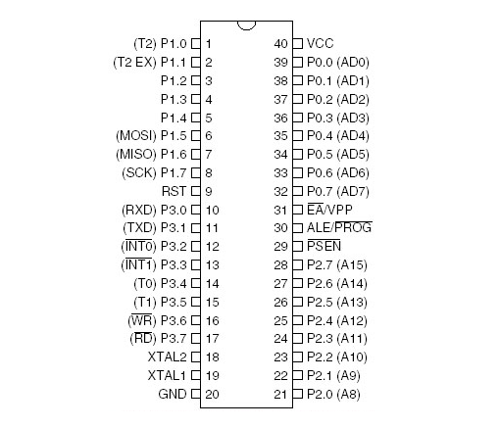 Fig 2.2: Pin Diagram of 89S52 Microcontroller
Pin Description
VCC
Supply voltage.
GND
Ground.
Port 0
Port 0 is an 8-bit open drain bidirectional I/O port. As an output port, each pin can sink eight TTL inputs. When 1s are written to port 0 pins, the pins can be used as highimpedance inputs.Port 0 can also be configured to be the multiplexed loworder address/data bus during accesses to external program and data memory. In this mode, P0 has internal pullups. Port 0 also receives the code bytes during Flash programming and outputs the code bytes during program verification.
External pull-ups are required during program verification.
Port 1
Port 1 is an 8-bit bidirectional I/O port with internal pullups. The Port 1 output buffers can sink/source four TTL inputs. When 1s are written to Port 1 pins, they are pulled high by the internal pullups and can be used as inputs. As inputs,Port 1 pins that are externally being pulled low will source current (IIL) because of the internal pullups. In addition, P1.0 and P1.1 can be configured to be the timer/counter 2 external count input (P1.0/T2) and the timer/counter 2 trigger input (P1.1/T2EX), respectively, as shown in the following table. Port 1 also receives the low-order address bytes during Flash programming and verification.
Port Pin | Alternate Functions
P1.0 | T2 (external count input to Timer/Counter 2). clock-out
P1.1 | T2EX (Timer/Counter 2 capture/reload trigger and direction control)
P1.5 | MOSI (used for In-System Programming)
P1.6 | MISO (used for In-System Programming)
P1.7 | SCK (used for in-System Programming)
Table 2.1: Alternate Functions of Port 1
Port 2
Port 2 is an 8-bit bidirectional I/O port with internal pullups. The Port 2 output buffers can sink/source four TTL inputs. When 1s are written to Port 2 pins, they are pulled high by
the internal pullups and can be used as inputs. As inputs, Port 2 pins that are externally being pulled low will source current (IIL) because of the internal pullups. Port 2 emits the high-order address byte during fetches from external program memory and during accesses to external data memory that use 16-bit addresses (MOVX @ DPTR). In this application, Port 2 uses strong internal pull-ups when emitting 1s. During accesses to external data memory that use 8-bit addresses (MOVX @ RI), Port 2 emits the contents of the P2 Special Function Register. Port 2 also receives the high-order address bits and some control signals during Flash programming and verification.
Port 3
Port 3 is an 8-bit bidirectional I/O port with internal pullups. The Port 3 output buffers can sink/source four TTL inputs. When 1s are written to Port 3 pins, they are pulled high by the internal pullups and can be used as inputs. As inputs, Port 3 pins that are externally being pulled low will source current (IIL) because of the pullups. Port 3 also serves the functions of various special features of the AT89S52, as shown in the following table. Port 3 also receives some control signals for Flash programming and verification.
Port Pin | Alternate Function
P3.0 | RXD (serial input port)
P3.1 | TXD (serial output port)
P3.2 | INTO (external interrupt)
P3.3 | INT1 (external interrupt)
P3.4 | TO (Timer/Counter O external input)
P3.5 | T1 (Timer/Counter 1 external input)
P3.6 | WR (external data memory write strobe)
P3.7 | RD (external data memory read strobe)
Table 2.2 Alternate Functions of Port 2
RST
Reset input A high on this pin for two machine cycles while the oscillator is running resets the device. This pin drives High for 96 oscillator periods after the Watchdog times out. The DISRTO bit in SFR AUXR (address 8EH) can be used to disable this feature. In the default state of bit DISRTO, the RESET HIGH out feature is enabled. ALE/PROG Address Latch Enable (ALE) is an output pulse for latching the low byte of the address during accesses to external memory. This pin is also the program pulse input (PROG) during Flash programming. In normal operation, ALE is emitted at a constant rate of 1/6 the oscillator frequency and may be used for external timing or clocking purposes. Note, however, that one ALE pulse is skipped during each access to external data memory. If desired, ALE operation can be disabled by setting bit 0 of SFR location 8EH. With the bit set, ALE is active only during a MOVX or MOVC instruction. Otherwise, the pin is weakly pulled high. Setting the ALE-disable bit has no effect if the microcontroller is in external execution mode.
PSEN
Program Store Enable (PSEN) is the read strobe to external program memory. When the AT89S52 is executing code from external program memory, PSEN is activated twice each machine cycle, except that two PSEN activations are skipped during each access to external data memory.
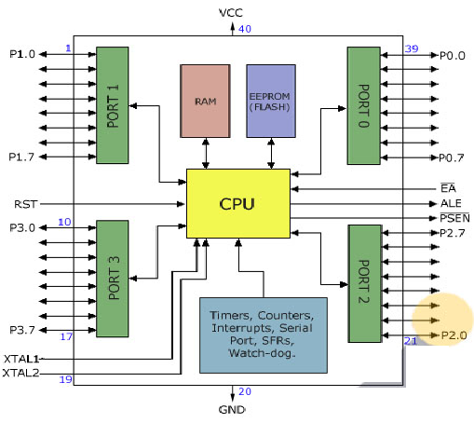
Fig 2.3: Functional Block Diagram of Microcontroller
EA/VPP
External Access Enable. EA must be strapped to GND in order to enable the device to fetch code from external program memory locations starting at 0000H up to FFFFH. Note, however, that if lock bit 1 is programmed, EA will be internally latched on reset. EA should be strapped to VCC for internal program executions. This pin also receives the 12-volt programming enable voltage
(VPP) during Flash programming.
XTAL1
Input to the inverting oscillator amplifier and input to the internal clock operating circuit.
XTAL2
Output from the inverting oscillator amplifier.
The 8052 Oscillator and Clock
The heart of the 8051 circuitry that generates the clock pulses by which all the internal all internal operations are synchronized. Pins XTAL1 And XTAL2 is provided for connecting a resonant network to form an oscillator. Typically a quartz crystal and capacitors are employed. The crystal frequency is the basic internal clock frequency of the microcontroller. The manufacturers make 8051 designs that run at specific minimum and maximum frequencies typically 1 to 16 MHz.
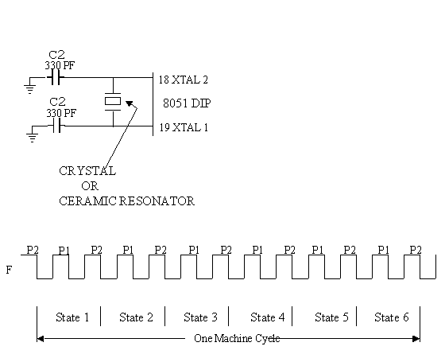
Fig 2.4: Oscillator and Timing Circuit
MEMORIES
Types of memory:
The 8052 have three general types of memory. They are on-chip memory, external Code memory and external Ram. On-Chip memory refers to physically existing memory on the micro controller itself. External code memory is the code memory that resides off chip. This is often in the form of an external EPROM. External RAM is the Ram that resides off chip. This often is in the form of standard static RAM or flash RAM.
a) Code memory
Code memory is the memory that holds the actual 8052 programs that is to be run. This memory is limited to 64K. Code memory may be found on-chip or off-chip. It is possible to have 8K of code memory on-chip and 60K off chip memory simultaneously. If only off-chip memory is available then there can be 64K of off chip ROM. This is controlled by pin provided as EA
b) Internal RAM
The 8052 have a bank of 256 bytes of internal RAM. The internal RAM is found on-chip. So it is the fastest Ram available. And also it is most flexible in terms of reading and writing. Internal Ram is volatile, so when 8051 is reset, this memory is cleared. 256 bytes of internal memory are subdivided. The first 32 bytes are divided into 4 register banks. Each bank contains 8 registers. Internal RAM also contains 256 bits, which are addressed from 20h to 2Fh. These bits are bit addressed i.e. each individual bit of a byte can be addressed by the user. They are numbered 00h to FFh. The user may make use of these variables with commands such as SETB and CLR.
Special Function registered memory
Special function registers are the areas of memory that control specific functionality of the 8052 micro controller.
a) Accumulator (0E0h)
As its name suggests, it is used to accumulate the results of large no of instructions. It can hold 8 bit values.
b) B registers (0F0h)
The B register is very similar to accumulator. It may hold 8-bit value. The b register is only used by MUL AB and DIV AB instructions. In MUL AB the higher byte of the product gets stored in B register. In div AB the quotient gets stored in B with the remainder in A.
- Stack pointer (81h)
- The stack pointer holds 8-bit value. This is used to indicate where the next value to be removed from the stack should be taken from. When a value is to be pushed onto the stack, the 8052 first store the value of SP and then store the value at the resulting memory location. When a value is to be popped from the stack, the 8052 returns the value from the memory location indicated by SP and then decrements the value of SP.
d) Data pointer
The SFRs DPL and DPH work together work together to represent a 16-bit value called the data pointer. The data pointer is used in operations regarding external RAM and some instructions code memory. It is a 16-bit SFR and also an addressable SFR.
e) Program counter
The program counter is a 16 bit register, which contains the 2 byte address, which tells the 8052 where the next instruction to execute to be found in memory. When the 8052 is initialized PC starts at 0000h. And is incremented each time an instruction is executes. It is not addressable SFR.

f) PCON (power control, 87h)
The power control SFR is used to control the 8051’s power control modes. Certain operation modes of the 8051 allow the 8051 to go into a type of “sleep mode” which consumes much lee power.
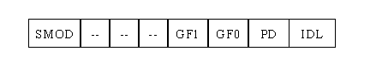
Fig 2.5: PCON Function Registers
g) TCON (timer control, 88h)
The timer control SFR is used to configure and modify the way in which the 8051’s two timers operate. This SFR controls whether each of the two timers is running or stopped and contains a flag to indicate that each timer has overflowed. Additionally, some non-timer related bits are located in TCON SFR. These bits are used to configure the way in which the external interrupt flags are activated, which are set when an external interrupt occurs.
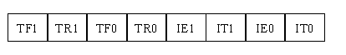
Fig 2.6: TCON Function Registers
h) TMOD (Timer Mode, 89h)
The timer mode SFR is used to configure the mode of operation of each of the two timers. Using this SFR your program may configure each timer to be a 16-bit timer, or 13 bit timer, 8-bit auto reload timer, or two separate timers. Additionally you may configure the timers to only count when an external pin is activated or to count “events” that are indicated on an external pin.
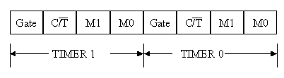
Fig 2.7: TMOD Function Registers
i) TO (Timer 0 low/high, address 8A/8C h)
These two SFRs taken together represent timer 0. Their exact behavior depends on how the timer is configured in the TMOD SFR; however, these timers always count up. What is configurable is how and when they increment in value.

j) T1 (Timer 1 Low/High, address 8B/ 8D h)
These two SFRs, taken together, represent timer 1. Their exact behavior depends on how the timer is configured in the TMOD SFR; however, these timers always count up.
k) P0 (Port 0, address 90h, bit addressable)
This is port 0 latch. Each bit of this SFR corresponds to one of the pins on a micro controller. Any data to be outputted to port 0 is first written on P0 register. For e.g., bit 0 of port 0 is pin P0.0, bit 7 is pin p0.7. Writing a value of 1 to a bit of this SFR will send a high level on the corresponding I/O pin whereas a value of 0 will bring it to low level.
l) P1 (port 1, address 90h, bit addressable)
This is port latch1. Each bit of this SFR corresponds to one of the pins on a micro controller. Any data to be outputted to port 0 is first written on P0 register. For e.g., bit 0 of port 0 is pin P1.0, bit 7 is pin P1.7. Writing a value of 1 to a bit of this SFR will send a high level on the corresponding I/O pin whereas a value of 0 will bring it to low level
m) P2 (port 2, address 0A0h, bit addressable):
This is a port latch2. Each bit of this SFR corresponds to one of the pins on a micro controller. Any data to be outputted to port 0 is first written on P0 register. For e.g., bit 0 of port 0 is pin P2.0, bit 7 is pin P2.7. Writing a value of 1 to a bit of this SFR will send a high level on the corresponding I/O pin whereas a value of 0 will bring it to low level.
n) P3 (port 3, address B0h, bit addressable)
This is a port latch3. Each bit of this SFR corresponds to one of the pins on a micro controller. Any data to be outputted to port 0 is first written on P0 register. For e.g., bit 0 of port 0 is pin P3.0, bit 7 is pin P3.7. Writing a value of 1 to a bit of this SFR will send a high level on the corresponding I/O pin whereas a value of 0 will bring it to low level.
o) IE (interrupt enable, 0A8h)
The Interrupt Enable SFR is used to enable and disable specific interrupts. The low 7 bits of the SFR are used to enable/disable the specific interrupts, where the MSB bit is used to enable or disable all the interrupts.
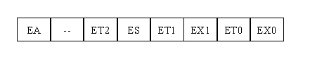
Fig 2.8: Interrupt Enable Function Registers
p) IP (Interrupt Priority, 0B8h)
The interrupt priority SFR is used to specify the relative priority of each interrupt. On 8051, an interrupt maybe either low or high priority. An interrupt may interrupt interrupts. For e.g., if we configure all interrupts as low priority other than serial interrupt. The serial interrupt always interrupts the system, even if another interrupt is currently executing. However, if a serial interrupt is executing no other interrupt will be able to interrupt the serial interrupt routine since the serial interrupt routine has the highest priority.
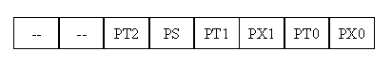
Fig 2.9: Interrupt Priority Function Registers
q) PSW (Program Status Word, 0D0h)
The program Status Word is used to store a number of important bits that are set and cleared by 8052 instructions. The PSW SFR contains the carry flag, the auxiliary carry flag, the parity flag and the overflow flag. Additionally, it also contains the register bank select flags, which are used to select, which of the “R” register banks currently in use.
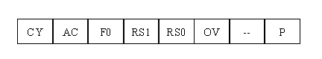
Fig 2.10: Program Status Word Function Registers
r) SBUF (Serial Buffer, 99h)
SBUF is used to hold data in serial communication. It is physically two registers. One is writing only and is used to hold data to be transmitted out of 8052 via TXD. The other is read only and holds received data from external sources via RXD. Both mutually exclusive registers use address 99h.
2.2 Power Supply
All digital circuits require regulated power supply. In this article we are going to learn how to get a regulated positive supply from the mains supply.
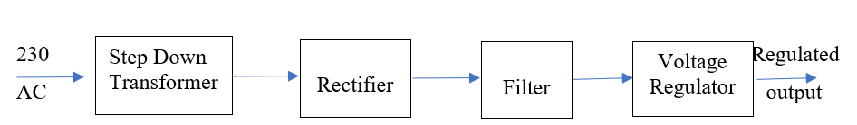
Fig 2.11: Power Supply
Figure 2.11 shows the basic block diagram of a fixed regulated power supply. Let us go through each block.
TRANSFORMER
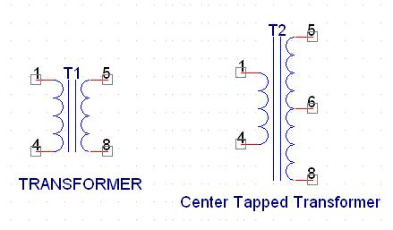
Fig 2.12: Center Tapped Transformer
A transformer consists of two coils also called as “WINDINGS” namely PRIMARY & SECONDARY.
They are linked together through inductively coupled electrical conductors also called as CORE. A changing current in the primary causes a change in the Magnetic Field in the core & this in turn induces an alternating voltage in the secondary coil. If load is applied to the secondary then an alternating current will flow through the load. If we consider an ideal condition then all the energy from the primary circuit will be transferred to the secondary circuit through the magnetic field.
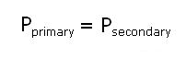
Rectifier
A rectifier is a device that converts an AC signal into DC signal. For rectification purpose we use a diode, a diode is a device that allows current to pass only in one direction i.e. when the anode of the diode is positive with respect to the cathode also called as forward biased condition & blocks current in the reversed biased condition.
Rectifier can be classified as follows:
1) Half Wave rectifier
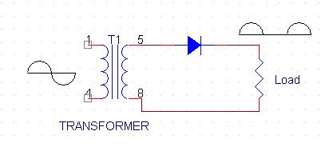
Fig 2.13: Circuit Diagram of Half Wave Rectifier
This is the simplest type of rectifier as you can see in the diagram a half wave rectifier consists of only one diode. When an AC signal is applied to it during the positive half cycle the diode is forward biased & current flows through it. But during the negative half cycle diode is reverse biased & no current flows through it. Since only one half of the input reaches the output, it is very inefficient to be used in power supplies.
2) Full wave rectifier
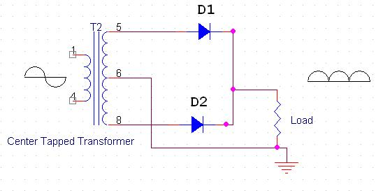
Fig 2.14: Circuit Diagram of Full Wave Rectifier
Half wave rectifier is quite simple but it is very inefficient, for greater efficiency we would like to use both the half cycles of the AC signal. This can be achieved by using a center tapped transformer i.e. we would have to double the size of secondary winding & provide connection to the center. So during the positive half cycle diode D1 conducts & D2 is in reverse biased condition. During the negative half cycle diode D2 conducts & D1 is reverse biased. Thus we get both the half cycles across the load.
3) Bridge Rectifier
.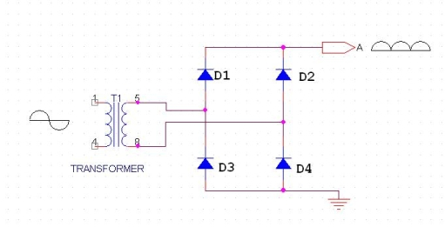
Fig 2.15: Circuit Diagram of Bridge Rectifier
As the name suggests it converts the full wave i.e. both the positive & the negative half cycle into DC thus it is much more efficient than Half Wave Rectifier & that too without using a center tapped transformer thus much more cost effective than Full Wave Rectifier.
Full Bridge Wave Rectifier consists of four diodes namely D1, D2, D3 and D4. During the positive half cycle diodes D1 & D4 conduct whereas in the negative half cycle diodes D2 & D3 conduct thus the diodes keep switching the transformer connections so we get positive half cycles in the output.
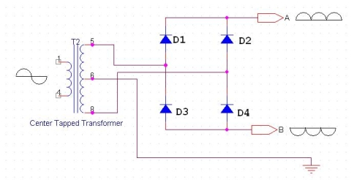
Fig 2.16: Circuit Diagram of Bridge Rectifier
If we use a center tapped transformer for a bridge rectifier we can get both positive & negative half cycles which can thus be used for generating fixed positive & fixed negative voltages.
Filter Capacitor
Even though half wave & full wave rectifier give DC output, none of them provides a constant output voltage. For this we require to smoothen the waveform received from the rectifier. This can be done by using a capacitor at the output of the rectifier this capacitor is also called as “FILTER CAPACITOR” or “SMOOTHING CAPACITOR” or “RESERVOIR CAPACITOR”. Even after using this capacitor a small amount of ripple will remain.
We place the Filter Capacitor at the output of the rectifier the capacitor will charge to the peak voltage during each half cycle then will discharge its stored energy slowly through the load while the rectified voltage drops to zero, thus trying to keep the voltage as constant. 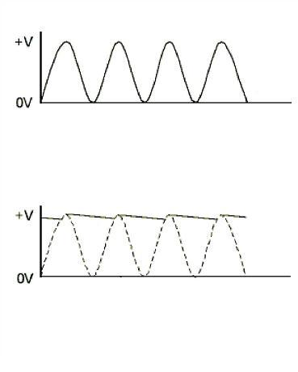
Fig 2.17: Rectified and Filtered Output Waveform
If we go on increasing the value of the filter capacitor then the Ripple will decrease. But then the costing will increase. The value of the Filter capacitor depends on the current Consumed by the circuit, the frequency of the waveform & the accepted ripple.
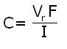

Where,
Vr= accepted ripple voltage.( should not be more than 10% of the voltage)
I= current consumed by the circuit in Amperes.
F= frequency of the waveform. A half wave rectifier has only one peak in one cycle so F=25hz
Whereas a full wave rectifier has Two peaks in one cycle so F=100hz.
Voltage Regulator
A Voltage regulator is a device which converts varying input voltage into a constant regulated output voltage. Voltage regulator can be of two types
1) Linear Voltage Regulator
Also called as Resistive Voltage regulator because they dissipate the excessive voltage resistively as heat.
2) Switching Regulators.
They regulate the output voltage by switching the Current ON/OFF very rapidly. Since their output is either ON or OFF it dissipates very low power thus achieving higher efficiency as compared to linear voltage regulators. But they are more complex & generate high noise due to their switching action. For low level of output power switching regulators tend to be costly but for higher output wattage they are much cheaper than linear regulators.
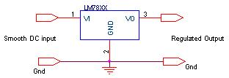
Fig 2.18: Voltage Regulator Circuit
After filtering the rectifier output the signal is given to a voltage regulator. The maximum input voltage that can be applied at the input is 35V.

2.2.1 Circuit diagram
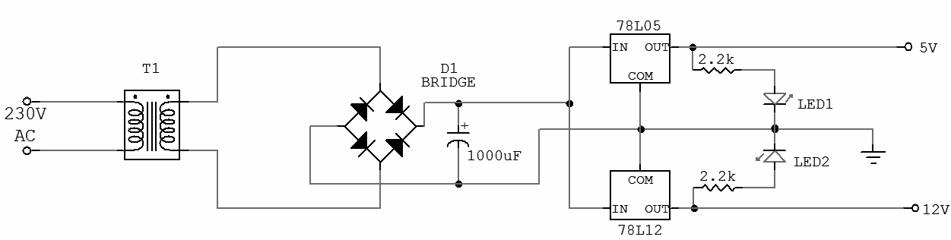
Fig 2.19: Circuit Diagram Of Power Supply

IC 7805
7805 is an integrated three-terminal positive fixed linear voltage regulator. It supports an input voltage of 10 volts to 35 volts and output voltage of 5 volts. It has a current rating of 1 amp although lower current models are available. Its output voltage is fixed at 5.0V. The 7805 also has a built-in current limiter as a safety feature. 7805 is manufactured by many companies, including National Semiconductors and Fairchild Semiconductors.

2.3 LCD
To display interactive messages we're using LCD Module. We take a look at an smart LCD show of lines, sixteen characters in keeping with line this is interfaced to the controllers. The protocol (handshaking) for the display is as proven. Whereas D0 to D7th bit is the Data strains, RS, RW and EN pins are the control pins and last pins are +5V, -5V and GND to offer supply. Where RS is the Register Select, RW is the Read Write and EN is the Enable pin.
The display consists of internal byte-wide registers, one for instructions (RS=zero) and the second for characters to be displayed (RS=1). It additionally includes a user-programmed RAM vicinity (the man or woman RAM) that may be programmed to generate any favored character that can be fashioned the usage of a dot matrix. To distinguish among these two facts regions, the hex command byte 80 could be used to indicate that the display RAM deal with 00h can be selected.Port1 is used to grant the command or statistics type, and ports 3.2 to3.4 provide register pick and study/write ranges.
The show takes various quantities of time to perform the features as listed. LCD bit 7 is monitored for common sense high (busy) to ensure the display is overwritten.Liquid Crystal Display also called as LCD may be very useful in offering user interface in addition to for debugging purpose. The most not unusual sort of LCD controller is HITACHI 44780 which provides a easy interface between the controller & an LCD. These LCD's are quite simple to interface with the controller as well as are price effective.
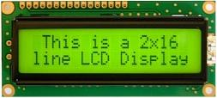
Fig 2.20: 2x16 LCD Display
The most commonly used ALPHANUMERIC displays are 1x16 (Single Line & 16 characters), 2x16 (Double Line & 16 character per line) & 4x20 (four lines & Twenty characters per line). The LCD requires 3 control lines (RS, R/W & EN) & 8 (or 4) data lines. The number on data lines depends on the mode of operation. If operated in 8-bit mode then 8 data lines + 3 control lines i.e. total 11 lines are required. And if operated in 4-bit mode then 4 data lines + 3 control lines i.e. 7 lines are required. How do we decide which mode to use? It’s simple if you have sufficient data lines you can go for 8 bit mode & if there is a time constrain i.e. display should be faster then we have to use 8-bit mode because basically 4-bit mode takes twice as more time as compared to 8-bit mode.
Pin | Symbol | Function
1 | Vss | Ground
2 | Vdd | Supply Voltage
3 | Vo | Contrast Setting
4 | RS | Register Select
5 | R/W | Read/Write Select
6 | En | Chip Enable Signal
7-14 | DB0-DB7 | Data Lines
15 | A/Vee | Gnd for the backlight
16 | K | Vcc for backlight

Table 2.3: Symbols and Functions of LCD Display
When RS is low (zero), the statistics is to be handled as a command. When RS is excessive (1), the records being sent is taken into consideration as textual content data which must be displayed on the screen. When R/W is low (0), the facts at the statistics bus is being written to the LCD. When RW is high (1), the program is effectively analyzing from the LCD. Most of the instances there's no need to read from the LCD so this line can immediately be linked to Gnd for that reason saving one controller line.

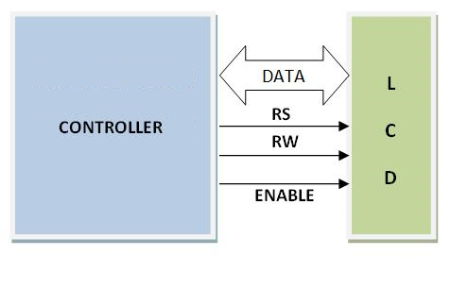
Fig 2.21: LCD Interfacing with Microcontroller
2.3.1Commands Used In LCD
N0 | Instruction | Hex | Decimal
1 | Function Set: 8-bit,1 Line,5x7 Dots | 0x30 | 48
2 | Function Set: 8-bit,2 Line,5x7 Dots | 0x38 | 56
3 | Function Set: 4-bit,1 Line,5x7 Dots | 0x20 | 32
4 | Function Set: 4-bit,2 Line,5x7 Dots | 0x28 | 40
5 | Entry Mode | 0x06 | 6
6 | Display off Cursor off  (clearing display without clearing DDRAM content) | 0x08 | 8
7 | Display on Cursor on | 0x0E | 14
8 | Display on Cursor off | 0x0C | 12
9 | Display on Cursor blinking | 0x0F | 15
10 | Shift Entire Display Left | 0x18 | 24
12 | Shift Entire Display Right | 0x1C | 30
13 | Move Cursor left by one character | 0x10 | 16
14 | Move Cursor right by one character | 0x14 | 20
15 | Clear Display (also clear DDRAM content) | 0x01 | 1

Table 2.4: Commands Used In LCD
2.4 IR SENSOR
An electroluminescent IR LED is a product which requires care in use. IR LEDs are fabricated from narrow band heterostructures with energy gap from 0.25 to 0.4 eV. That's why the bias used to initiate current flow is low compared to the well known visible or NIR LEDs. Typical forward bias is V~0.1- 1 V only for mid-IR LEDs.
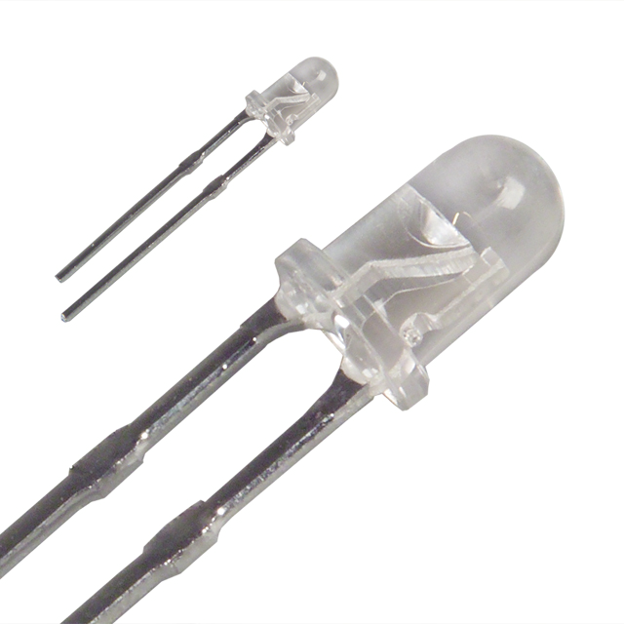
Fig 2.22: IR Sensor
Be sure not to exceed I*max which is given in each LED specification and do not use test instrument that contain sources/batteries with voltage greater that V_{cw} max given in specification. For LED current restriction and further LED current measurement we recommend to use resistor (1-5 Ohms) connected in serial to LED. This is important to note that un-grounded devices (e.g. computers) can give V=1-5 V that is enough to destroy the LED.
It is highly desirable that the user has I-V meter for small currents (10-100 x10⁻⁶ A). We guarantee the existence of the LED output as long as V-I characteristic shows saturation in the reverse bias (10-100 x10⁻⁶ A).We recommend activating pulse generator prior connecting LED to generator. On switching off the procedure is reversed: disconnect LED, switch off pulse generator. Long wires connecting LED with pulse generator may be the reason for LED failure because of unexpected voltage surges when switching on and off the LED supply.Please test all elements and circuits before applying voltage to LED. Remember that ground (T0-18 or another holder) should be biased positively (if not specially designed). Usually the negative electrode is made shorter than the positive one.The expected signal is not very big and it is important to test and eliminate noise in the detector circuits.
In some cases it is possible to increase pulse duration. Imax in such cases can be estimated using the following equation: Imax=I* max /20*SQRT(f*t), where f-is the frequency (Hz), t-is the pulse duration (s), I* max-is the maximum current (A) for t=5 us and f=500 Hz. The equation gives an order of magnitude and may be used for t< 0.1 ms only. Pulses with t > 0.15 ms should be considered as adequate to CW operation and Imax and Vmax should be taken close to CW operation parameters. Please, note that long pulses can increase heat dissipation and the chip temperature. This effect decreases LED emission power and can be traced due to the LED resistance decrease during each pulse. CW power often decreases with time due to heatsink temperature increase.Micro immersion LEDs are made with chalcogenide glass that have low melting temperature (50-70oC). That’s why, please, avoid any heater source close to the LED. Even sunlight concentrated onto the lens can melt glass the lens. That’s why we recommend vertical position for the LEDs at the initial stage of the research work. We are working now to increase the glass melting temperature or/and to strengthen its position and shape.
Be patient in adjusting the optical system. It is only experience that allows fast work.
Lifetime Tests
Room temperature lifetime tests were performed with InGaAs homojunction diodes, un-encapsulated and encapsulated at current pulses of 2A, duration 50 µs and repetition rate of 30 Hz.Lower figure presents data on the long-term variation of the properties of the uncoated InGaAs homojunction LED s at high temperatures. The upper graph shows the times for which the LEDs under study operated at several ambient temperatures. The samples operated at currents I = 0, 0.5, 1, 2 A for 150 h at room temperature, 450 h at T = 130°C, and 800 h at T =180°C. The LEDs were cooled to room temperature and heated again to T = 130°C eight times and to 180°C three times.
The lower graph shows the output power as a function of the working time. As can be seen, the output power decreased, on average, by 25% after 1400 h of operation. It is noteworthy that the operating current strength has no effect on the degradation of the LEDs. With increasing operating time, the reverse currents at a bias U = 1 V increased from 0.5–1 mA (0 h) to 3–4 mA (1400 h). On “cleaning” the sample surface by etching in CP-4, the reverse current returned to its initial values, and the output power tended to regain its initial value: P(1400 h) = (0.85–0.9)P(0 h).
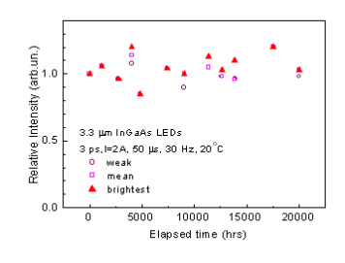

Fig 2.23: IR Led Life Time Tests
2.5 SPDT RELAY

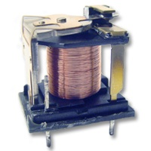

Fig 2.23: SPDT Relay

Overview OF Relays

A relay is an electrically operated switch used to isolate one electrical circuit from another. In its simplest form, a relay consists of a coil used as an electromagnet to open and close switch contacts. Since the two circuits are isolated from one another, a lower voltage circuit can be used to trip a relay, which will control a separate circuit that requires a higher voltage or amperage. Relays can be found in early telephone exchange equipment, in industrial control circuits, in car audio systems, in automobiles, on water pumps, in high-power audio amplifiers and as protection devices.

Relay Switch Contacts
The switch contacts on a relay can be "normally open" (NO) or "normally closed" (NC)--that is, when the coil is at rest and not energized (no current flowing through it), the switch contacts are given the designation of being NO or NC. In an open circuit, no current flows, such as a wall light switch in your home in a position that the light is off. In a closed circuit, metal switch contacts touch each other to complete a circuit, and current flows, similar to turning a light switch to the "on" position. In the accompanying schematic diagram, points A and B connect to the coil. Points C and D connect to the switch.

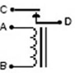
When you apply a voltage across the coil at points A and B, you create an electromagnetic field, which attracts a lever in the switch, causing it to make or break contact in the circuit atpoints C and D (depending if the design is NO or NC). The switch contacts remain in this state until you remove the voltage to the coil. Relays come in different switch configurations. The switches may have more than one "pole," or switch contact. The diagram shows a "single pole single throw" configuration, referred to as SPST. This is similar to a wall light switch in your home. With a single "throw" of the switch, you close the circuit.

The Single Pole Double Throw Relay

A single pole double throw (SPDT) relay configuration switches one common pole to two other poles, flipping between them. As shown in the schematic diagram, the common point E completes a circuit with C when the relay coil is at rest, that is, no voltage is applied to it.

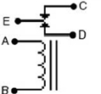

This circuit is "closed." A gap between the contacts of point E and D creates an "open" circuit. When you apply power to the coil, a metal level is pulled down, closing the circuit between points E and D and opening the circuit between E and C. A single pole double throw relay can be used to alternate which circuit a voltage or signal will be sent to.

SPDT Relay:
(Single Pole Double Throw Relay) an electromagnetic switch, consist of a coil (terminals 85 & 86), 1 common terminal (30), 1 normally closed terminal (87a), and one normally open terminal (87) (Figure 1).
When the coil of an SPDT relay (Figure 1) is at rest (not energized), the common terminal (30) and the normally closed terminal (87a) have continuity. When the coil is energized, the common terminal (30) and the normally open terminal (87) have continuity.
The diagram below center (Figure 2) shows an SPDT relay at rest, with the coil not energized. The diagram below right (Figure 3) shows the relay with the coil energized. As you can see, the coil is an electromagnet that causes the arm that is always connected to the common (30) to pivot when energized whereby contact is broken from the normally closed terminal (87a) and made with the normally open terminal (87).
When energizing the coil of a relay, polarity of the coil does not matter unless there is a diode across the coil. If a diode is not present, you may attach positive voltage to either terminal of the coil and negative voltage to the other, otherwise you must connect positive to the side of the coil that the cathode side (side with stripe) of the diode is connected and negative to side of the coil that the anode side of the diode is connected.
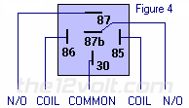

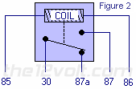
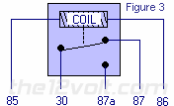

Why do I want to use a relay and do I really need to
Anytime you want to switch a device which draws more current than is provided by an output of a switch or component you'll need to use a relay. The coil of an SPDT or an SPST relay that we most commonly use draws very little current (less than 200 milliamps) and the amount of current that you can pass through a relay's common, normally closed, and normally open contacts will handle up to 30 or 40 amps. This allows you to switch devices such as headlights, parking lights, horns, etc., with low amperage outputs such as those found on keyless entry and alarm systems, and other components. In some cases you may need to switch multiple things at the same time using one output. A single output connected to multiple relays will allow you to open continuity and/or close continuity simultaneously on multiple wires.
There are far too many applications to list that require the use of a relay, but we do show many of the most popular applications in the pages that follow and many more in our Relay Diagrams - Quick Reference application. If you are still unclear about what a relay does or if you should use one after you browse through the rest of this section, please post a question in the12volt's install bay. (We recommend Tyco (formerly Bosch) or Potter & Brumfield relays for all of the SPDT and SPST relay applications shown on this site.)
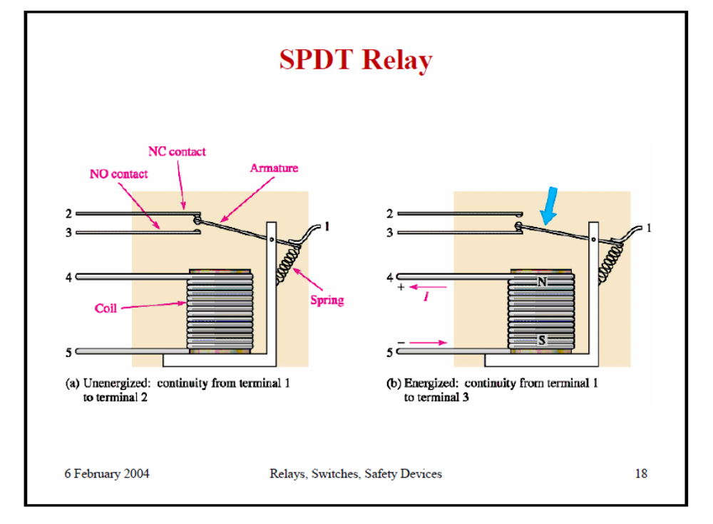
2.6 BUZZER
A buzzer or beeper is an audio signaling device, which may be mechanical, electromechanical, or electronic. Typical uses of buzzers and beepers include alarms, timers and confirmation of user input such as a mouse click or keystroke.
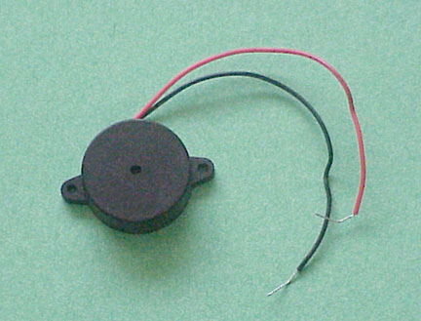
FEATURES
- The PB series are high-performance buzzers with a unimorph piezoelectric ceramic element and an integral self-excitation oscillator circuit.
- They exhibit extremely low power consumption in comparison to electromagnetic units.
- They are constructed without switching contacts to ensure long life and no electrical noise.
- Compact, yet produces high acoustic output with minimal voltage.

Mechanical
A joy buzzer is an example of a purely mechanical buzzer.

Electromechanical
Early devices were based on an electromechanical system identical to an electric bell without the metal gong. Similarly, a relay may be connected to interrupt its own actuating current, causing the contacts to buzz. Often these units were anchored to a wall or ceiling to use it as a sounding board. The word "buzzer" comes from the rasping noise that electromechanical buzzers made.
VOLTAGE BUZZER SOUND CONTROLS
When resistance is connected in series (as shown in illustrations (a) and (b)), abnormal oscillation may occur when adjusting the sound volume. In this case, insert a capacitor in parallel to the voltage oscillation board (as shown in illustration (c)). By doing so, abnormal oscillation can be prevented by grounding one side. However, the voltage VB added to the voltage oscillation board must be within the maximum input voltage range, and as capacitance of 3.3μF or greater should be connected.

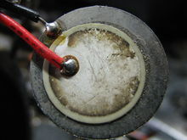
A piezoelectric element may be driven by an oscillating electronic circuit or other audio signal source. Sounds commonly used to indicate that a button has been pressed are a click, a ring or a beep. Electronic buzzers find many applications in modern days.

Uses
- Annunciator panels
- Electronic metronomes
- Game shows
- Microwave ovens and other household appliances
- Sporting events such as basketball games

2.7 DCMOTOR

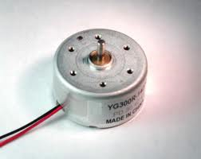
DC motors are configured in many types and sizes, including brush less, servo, and gear motor types. A motor consists of a rotor and a permanent magnetic field stator. The magnetic field is maintained using either permanent magnets or electromagnetic windings. DC motors are most commonly used in variable speed and torque.
Motion and controls cover a wide range of components that in some way are used to generate and/or control motion. Areas within this category include bearings and bushings, clutches and brakes, controls and drives, drive components, encoders and resolves, Integrated motion control, limit switches, linear actuators, linear and rotary motion components, linear position sensing, motors (both AC and DC motors), orientation position sensing, pneumatics and pneumatic components, positioning stages, slides and guides, power transmission.
Motors are the devices that provide the actual speed and torque in a drive system. This family includes AC motor types (single and multiphase motors, universal, servo motors, induction, synchronous, and gear motor) and DC motors (brush less, servo motor, and gear motor) as well as linear, stepper and air motors, and motor contactors and starters.In any electric motor, operation is based on simple electromagnetism. A current-carrying conductor generates a magnetic field; when this is then placed in an external magnetic field, it will experience a force proportional to the current in the conductor, and to the strength of the external magnetic field. As you are well aware of from playing with magnets as a kid, opposite (North and South) polarities attract, while like polarities (North and North, South and South) repel. The internal configuration of a DC motor is designed to harness the magnetic interaction between a current-carrying conductor and an external magnetic field to generate rotational motion.
Let's start by looking at a simple 2-pole DC electric motor (here red represents a magnet or winding with a "North" polarization, while green represents a magnet or winding with a "South" polarization).
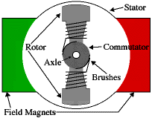
Every DC motor has six basic parts -- axle, rotor (a.k.a., armature), stator, commutator, field magnet(s), and brushes. In most common DC motors (and all that Beamers will see), the external magnetic field is produced by high-strength permanent magnets1. The stator is the stationary part of the motor -- this includes the motor casing, as well as two or more permanent magnet pole pieces. The rotor (together with the axle and attached commutator) rotates with respect to the stator. The rotor consists of windings (generally on a core), the windings being electrically connected to the commutator. The above diagram shows a common motor layout -- with the rotor inside the stator (field) magnets.
The geometry of the brushes, commutator contacts, and rotor windings are such that when power is applied, the polarities of the energized winding and the stator magnet(s) are misaligned, and the rotor will rotate until it is almost aligned with the stator's field magnets. As the rotor reaches alignment, the brushes move to the next commutator contacts, and energize the next winding. Given our example two-pole motor, the rotation reverses the direction of current through the rotor winding, leading to a "flip" of the rotor's magnetic field, and driving it to continue rotating.
In real life, though, DC motors will always have more than two poles (three is a very common number). In particular, this avoids "dead spots" in the commutator. You can imagine how with our example two-pole motor, if the rotor is exactly at the middle of its rotation (perfectly aligned with the field magnets), it will get "stuck" there. Meanwhile, with a two-pole motor, there is a moment where the commutator shorts out the power supply (i.e., both brushes touch both commutator contacts simultaneously). This would be bad for the power supply, waste energy, and damage motor components as well. Yet another disadvantage of such a simple motor is that it would exhibit a high amount of torque” ripple" (the amount of torque it could produce is cyclic with the position of the rotor).
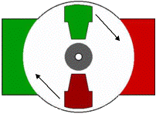
So since most small DC motors are of a three-pole design, let's tinker with the workings of one via an interactive animation (JavaScript required):
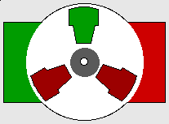
You'll notice a few things from this -- namely, one pole is fully energized at a time (but two others are "partially" energized). As each brush transitions from one commutator contact to the next, one coil's field will rapidly collapse, as the next coil's field will rapidly charge up (this occurs within a few microsecond). We'll see more about the effects of this later, but in the meantime you can see that this is a direct result of the coil windings' series wiring:
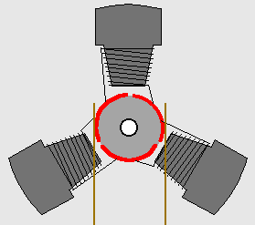
There's probably no better way to see how an average dc motor is put together, than by just opening one up. Unfortunately this is tedious work, as well as requiring the destruction of a perfectly good motor.

Chapter- III
CIRCUIT DIAGRAM
3.1 Circuit diagram

PLEASE COPY YOUR CIRCUIT DIAGRAM

Fig 3.1 Project circuit diagram
SOURCE CODE
3.1 Source Code

PLEASE COPY YOUR FINAL CODE

SOFTWARE DEVELOPMENT
3.1 Introduction:
In this chapter the software used and the language in which the program code is defined is mentioned and the program code dumping tools are explained. The chapter also documents the development of the program for the application. This program has been termed as “Source code”. Before we look at the source code we define the two header files that we have used in the code.
3.2 Tools Used:
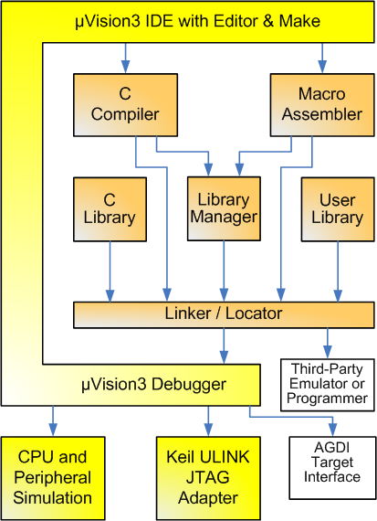
Figure 5.2 Keil Software- internal stages

3.3 C51 Compiler & A51 Macro Assembler:
Source files are created by the µVision IDE and are passed to the C51 Compiler or A51 Macro Assembler. The compiler and assembler process source files and create replaceable object files.
The Keil C51 Compiler is a full ANSI implementation of the C programming language that supports all standard features of the C language. In addition, numerous features for direct support of the 8051 architecture have been added.
3.4 START µVISION

What's New in µVision3?
µVision3 adds many new features to the Editor like Text Templates, Quick Function Navigation, and Syntax Coloring with brace high lighting Configuration Wizard for dialog based startup and debugger setup. µVision3 is fully compatible to µVision2 and can be used in parallel with µVision2.

What is µVision3?
µVision3 is an IDE (Integrated Development Environment) that helps you write, compile, and debug embedded programs. It encapsulates the following components:
- A project manager.
- A make facility.
- Tool configuration.
- Editor.
- A powerful debugger.
To help you get started, several example programs (located in the \C51\Examples, \C251\Examples, \C166\Examples, and \ARM\...\Examples) are provided.
- HELLO is a simple program that prints the string "Hello World" using the Serial Interface.
- MEASURE is a data acquisition system for analog and digital systems.
- TRAFFIC is a traffic light controller with the RTX Tiny operating system.
- SIEVE is the SIEVE Benchmark.
- DHRY is the Dhrystone Benchmark.
- WHETS are the Single-Precision Whetstone Benchmark.
Additional example programs not listed here are provided for each device architecture. BUILDING AN APPLICATION IN µvision
To build (compile, assemble, and link) an application in µVision2, you must:

Select Project -(forexample,166\EXAMPLES\HELLO\HELLO.UV2).

Select Project - Rebuild all target files or Build target.
µVision2 compiles, assembles, and links the files in your project.
Creating Your Own Application in µVision2
To create a new project in µVision2, you must:
- Select Project - New Project.
- Select a directory and enter the name of the project file.
- Select Project - Select Device and select an 8051, 251, or C16x/ST10 device from the Device Database™.
- Create source files to add to the project.
- Select Project - Targets, Groups, Files. Add/Files, select Source Group1, and add the source files to the project.
- Select Project - Options and set the tool options. Note when you select the target device from the Device Database™ all special options are set automatically. You typically only need to configure the memory map of your target hardware. Default memory model settings are optimal for most applications.
- Select Project - Rebuild all target files or Build target.

Debugging an Application in µVision2
To debug an application created using µVision2, you must:
- Select Debug - Start/Stop Debug Session.
- Use the Step toolbar buttons to single-step through your program. You may enter G, main in the Output Window to execute to the main C function.
- Open the Serial Window using the Serial #1 button on the toolbar.
Debug your program using standard options like Step, Go, Break, and so on.
4.5 Overview Of Keil Uvision Software
Click on the Keil uVision Icon on Desktop
The following fig will appear

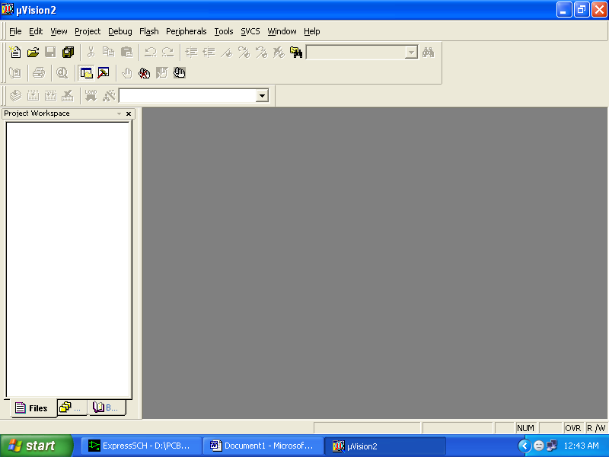

Click on the Project menu from the title bar
Then Click on New Project

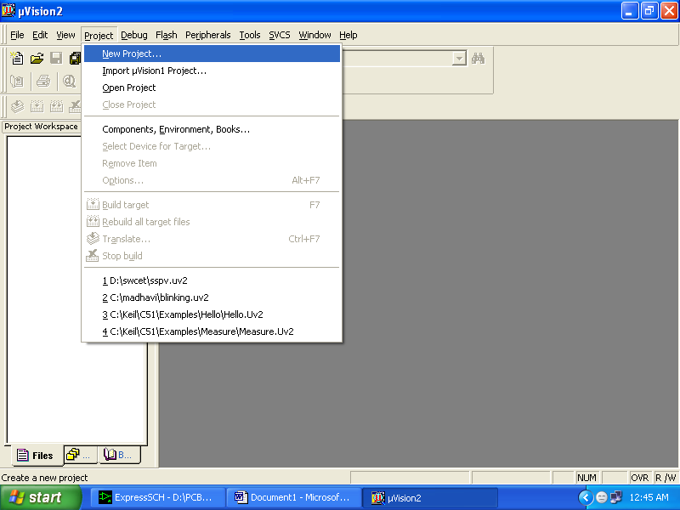

Save the Project by typing suitable project name with no extension in u r own folder sited in either C:\ or D:\

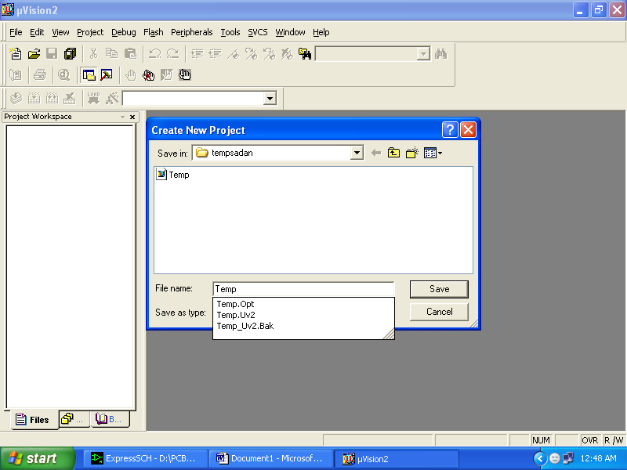

Then Click on Save button above.
Select the component for u r project. i.e. Atmel……
Click on the + Symbol beside of Atmel

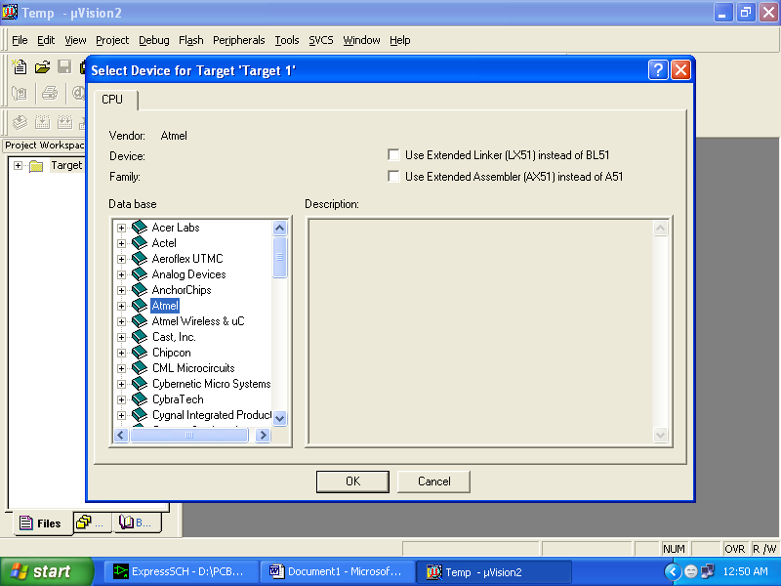

Select AT89S52 as shown below

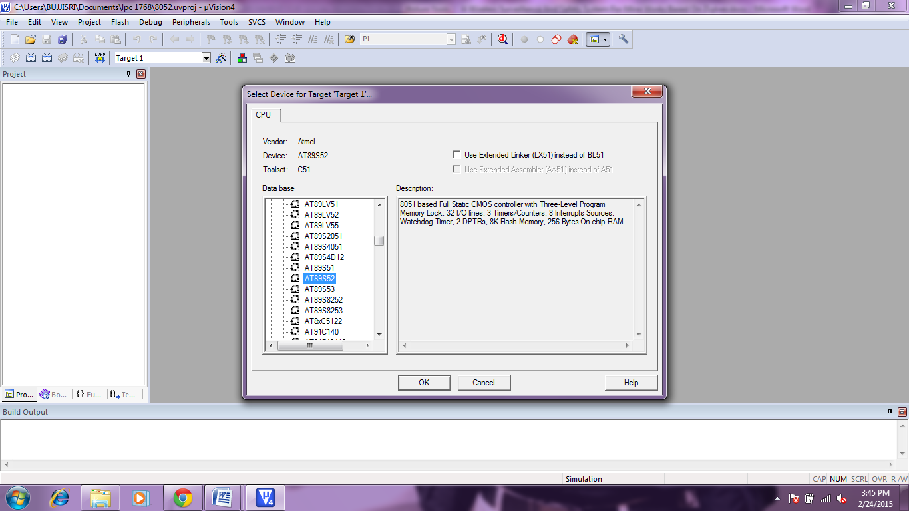

Then Click on “OK”
The Following fig will appear

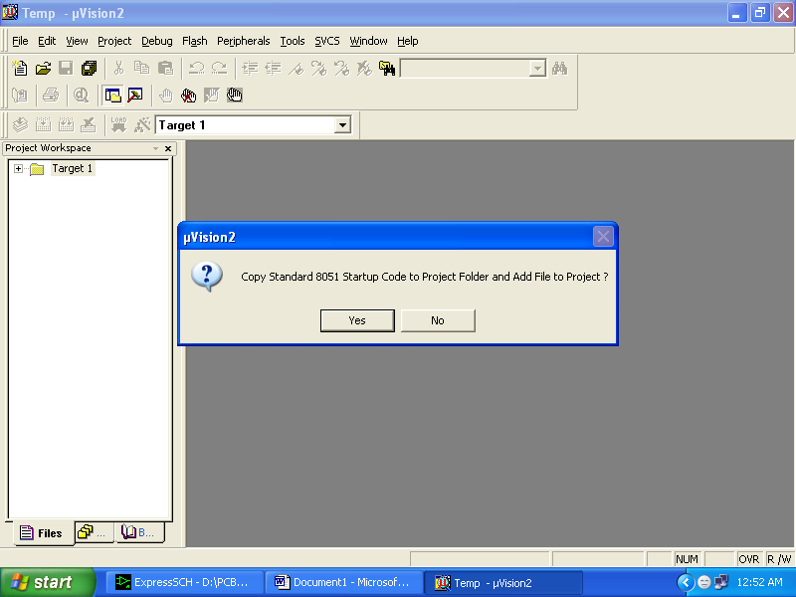

Then Click either YES or NO………mostly “NO”
Now your project is ready to USE
Now double click on the Target1, you would get another option “Source group 1” as shown in next page.
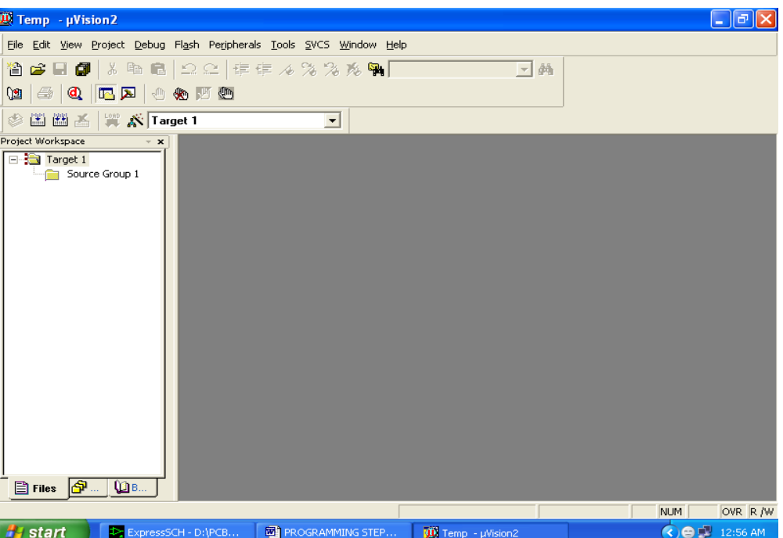

Click on the file option from menu bar and select “new”

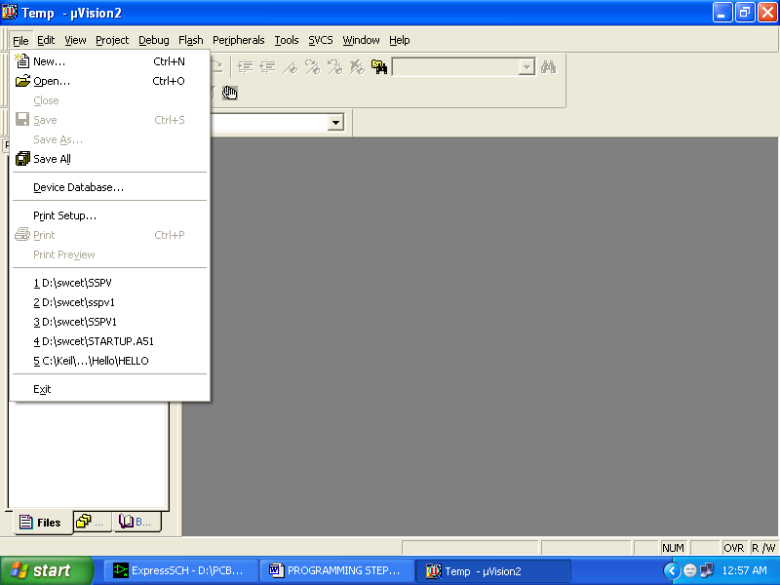

The next screen will be as shown in next page, and just maximize it by double clicking on its blue boarder.
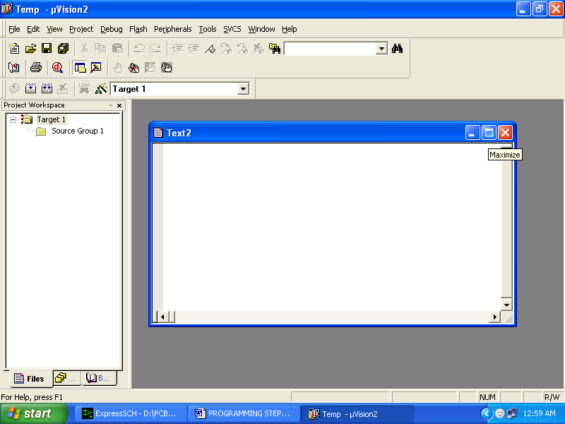

Now start writing program in either in “C” or “ASM”
For a program written in Assembly, then save it with extension “. asm” and for “C” based program save it with extension “ .C”

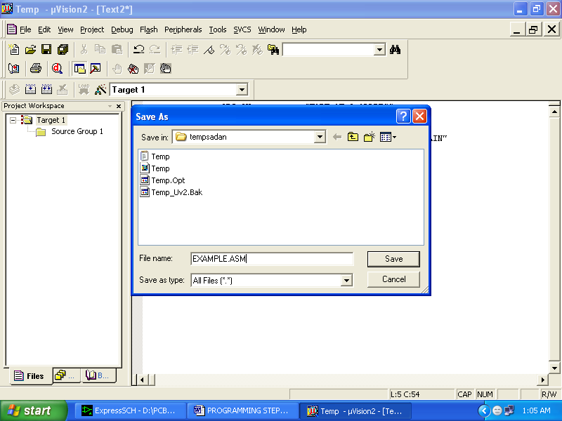
Now right click on Source group 1 and click on “Add files to Group Source”
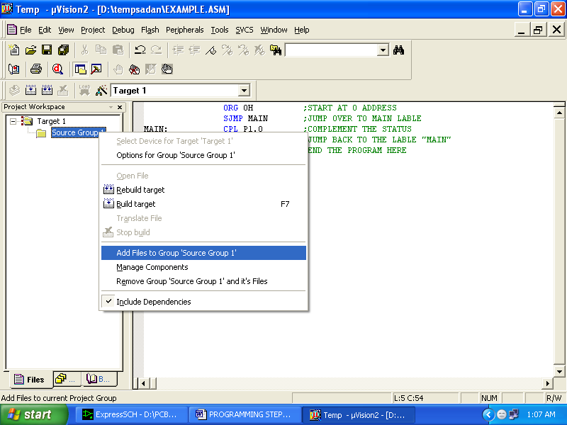
Now you will get another window, on which by default “C” files will appear.

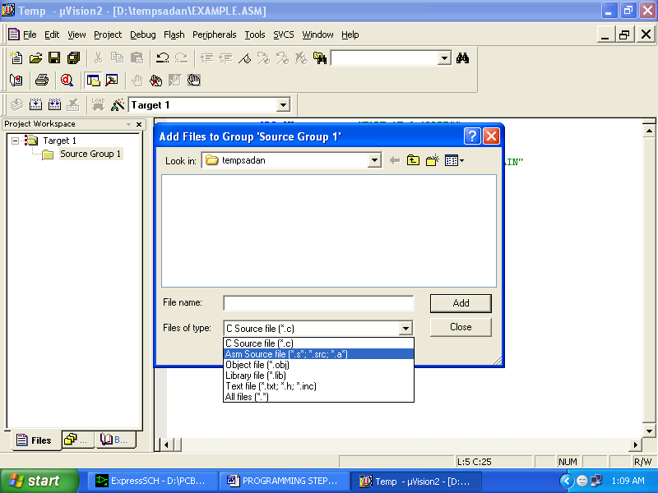
Now select as per your file extension given while saving the file
Click only one time on option “ADD”
Now Press function key F7 to compile. Any error will appear if so happen.
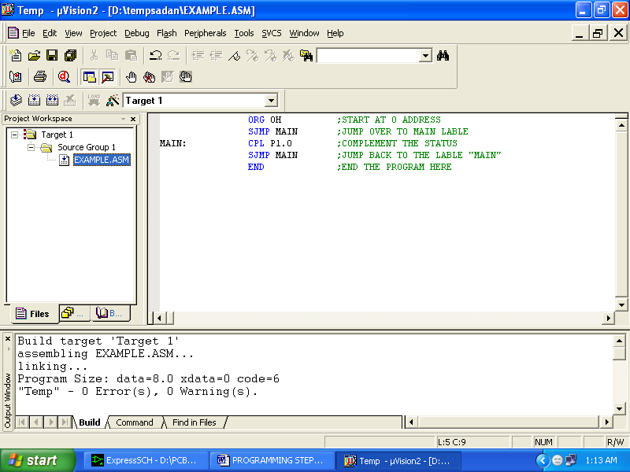
If the file contains no error, then press Control+F5 simultaneously.
The new window is as follows
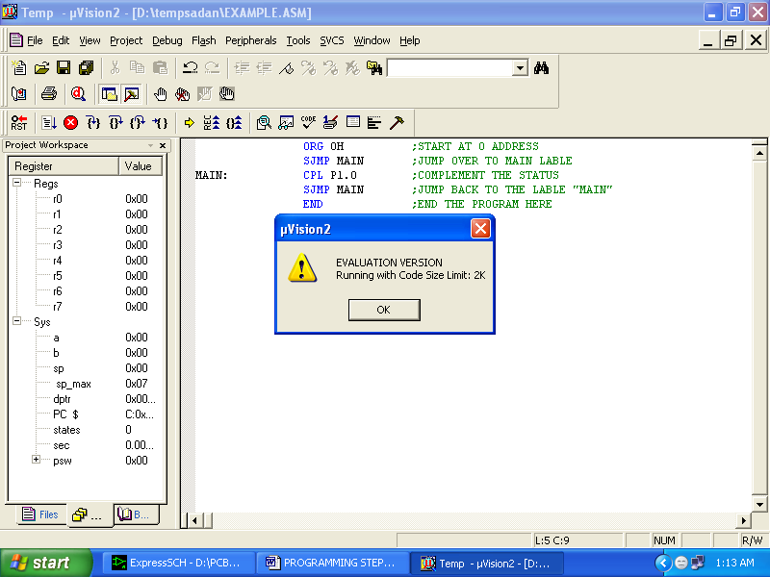
Then Click “OK”
Now Click on the Peripherals from menu bar, and check your required port as shown in fig below
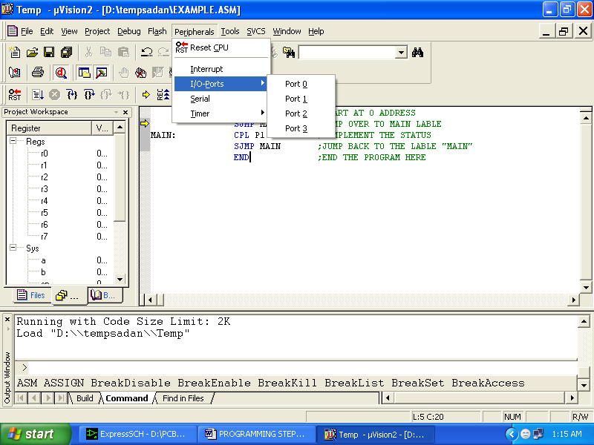
Drag the port a side and click in the program file.

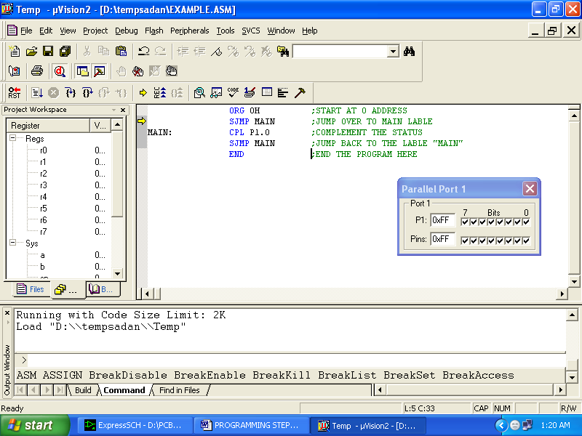

Chapter- IV
CONCLUSION

4.1 Conclusion
The project has been successfully designed and tested. Integrating features of all the hardware components used have developed it. Presence of every module has been reasoned out and placed carefully thus contributing to the best working of the unit. Secondly, using highly advanced IC’s and with the help of growing technology the project has been successfully implemented.

